Adding feature to Sketcher workbench

Aim : add a new feature to sketcher workbench of FreeCAD. We will try to add a chamfer tool, similar to the fillet tool. Also we will add a “polyChamfer” tool, that will make a chamfer with several edges.
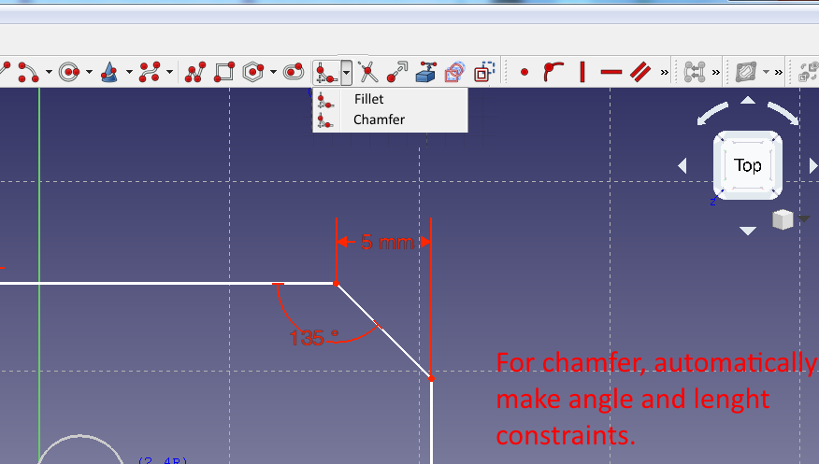

Sketcher code is located in freecad-source/src/Mod/Sketcher/

Two main folders, App for the backend, GUI for interface.

The general way to do it that we’ll use, is to search for “fillet” on the folder to understand what needs to be implemented.

1 – Create icone
Sketcher/Gui/Resources/icons/

Using inkscape we make our icon based on Sketcher_CreateFillet.svg.
We made Sketcher_CreateChamfer.svg and Sketcher_CreatePolyChamfer.svg
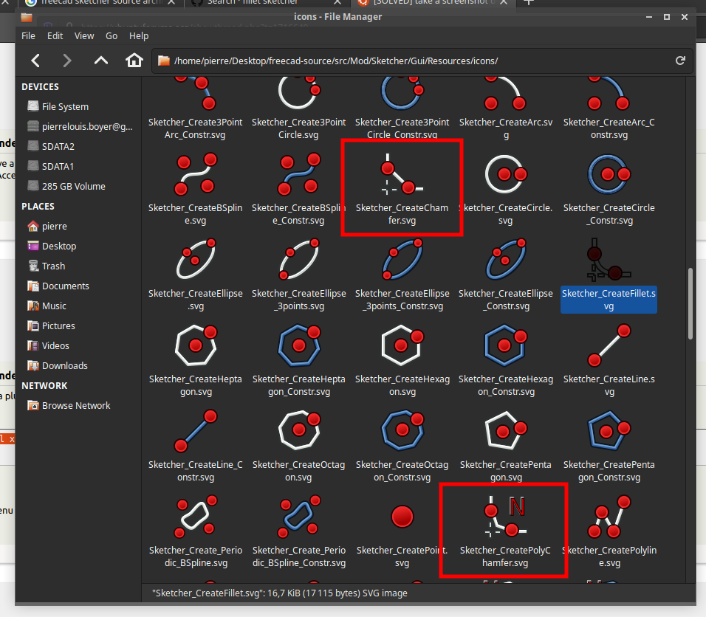

2 – Add icon to Sketcher/Gui/Resources/Sketcher.qrc
Let’s add each line at the correct alphabetic position as we don’t know if it has an importance :

<file>icons/Sketcher_CreateChamfer.svg</file>
<file>icons/Sketcher_CreatePolyChamfer.svg</file>

3- file src/Mod/Sketcher/Gui/CommandCreateGeo.cpp
This file is one of those found by searching “fillet” in the sketcher folder. A ctrl-F on google chrome let us see where fillet is located on the file.
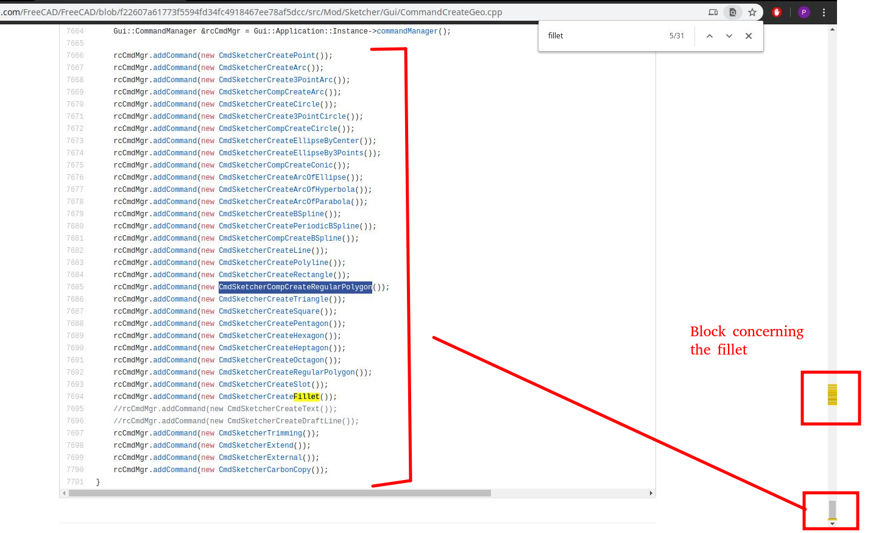
“fillet” appears a lot on one place of the file, and once at the bottom.
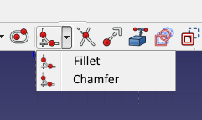
The bottom looks like the command panel making. As we want to include several tools in the same dropdown as polygons. Like this :
We can analyse how it’s done for the polygon tool.
See there is a CompCreateRegularPolygon which looks like the dropdown thing. So we will replicate this.

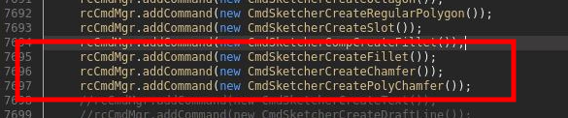
Then we will check the CompCreateRegularPolygon class and replicate. Also we will use the fillet class as basis for our CreateChamfer and CreatePolyChamfer.

When we look at the block of code, there is a handler class :
“class DrawSketchHandlerFillet: public DrawSketchHandler”
Which defines the actions to take when an action is selected (mouse click, mouse move...). For polygon there is only one handler class with a parameter (number of side of polygon). We will replicate this by using the number of angle. Where 1 will be fillet, 2 chamfer, 3+ polychamfers. Also we will use negative numbers to make ‘inward’ fillet and polychamfers.
So we need to add a nof_angle int parameter to the handler.
Also for each command there are few functions to implement :
DEF_STD_CMD_A(CmdSketcherCreateFillet)
CmdSketcherCreateFillet::CmdSketcherCreateFillet() : Command("Sketcher_CreateFillet")
void CmdSketcherCreateFillet::activated(int iMsg)
bool CmdSketcherCreateFillet::isActive(void)

For the “comp” (dropdown) button, there are few more functions. We copy from the polygon tool the structure. The polygon use a window to get user input number of side. We replicate also this and associated files to make a window asking for number of angle.

So the handler function catches the user clicked geometry. Then it launch a command to the app side of the workbench by this structure :
try {
Gui::Command::openCommand("Create fillet");
Gui::cmdAppObjectArgs(sketchgui->getObject(), "fillet(%d,%d,App.Vector(%f,%f,0),App.Vector(%f,%f,0),%f,%d)", firstCurve, secondCurve, firstPos.x, firstPos.y, secondPos.x, secondPos.y, radius, nofAngles);
Gui::Command::commitCommand();
}
The app side of the workbench will create the geometry. Note that we added the parameter nofAngles here. Note the handler is doing few other things, like finding the radius. I’m not sure why this is done on the GUI side and not on the APP side?
Sketcher/Gui/CommandAlterGeometry.cpp
in “// list of toggle construction commands.” Add :
rcCmdMgr.addCommandMode("ToggleConstruction", "Sketcher_CompCreateFillet");

Sketcher/Gui/Workbench.cpp
Here we need to mofidy the menu to add our chamfer tool.

sketcher/app/SketchObject.cpp
This is where the APP side of fillet is done. A ctrl+F let us find the block of code talking about fillet. There are two functions, though the first one just modify parameters before calling the second (main) one.
int SketchObject::fillet(int GeoId1, int GeoId2,
const Base::Vector3d& refPnt1, const Base::Vector3d& refPnt2,
double radius, int nofAngles, bool trim)
Here we add the nofAngles parameter. Also we think about adding it in the sketchobject.h file. In the .h file we will also define default value of 1 for this parameter. Such that if the function is called from somewhere else, it’s not broken if the nofAngles is not declared.
So now we will try to modify this function. After a short analysis, the function create the fillet arc by calling a function :
Part::GeomArcOfCircle *arc = Part::createFilletGeometry(lineSeg1, lineSeg2, filletCenter, radius);
after checking it this function is located yet another place, in the part workbench. No idea why it’s in the part workbench though as I though part are 3D things?

mode/part/app/geometry.cpp
So here we will need to add an optional parameter ‘inward’ that will create the arc inward instead of usual outward fillet.
Note we don’t want using the same center for the arc. Because if we do so we’ll end up with something like the big arc here. And what we want is the small arc. Or do we want both? Not sure there is much use-case for the big arc.
